Result Discussion

Fist version RF
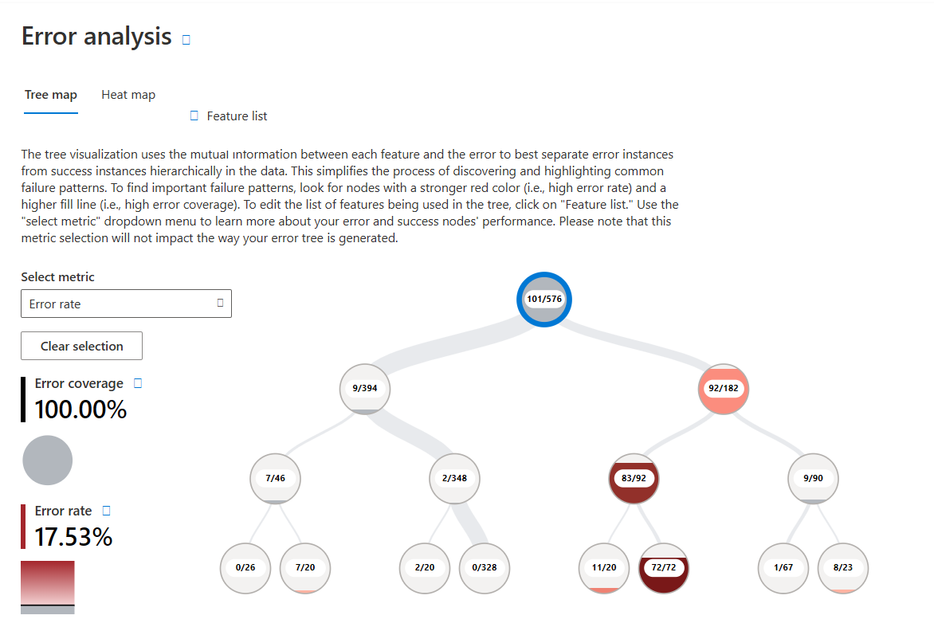

Accuracy :0.825

After Retrain RF
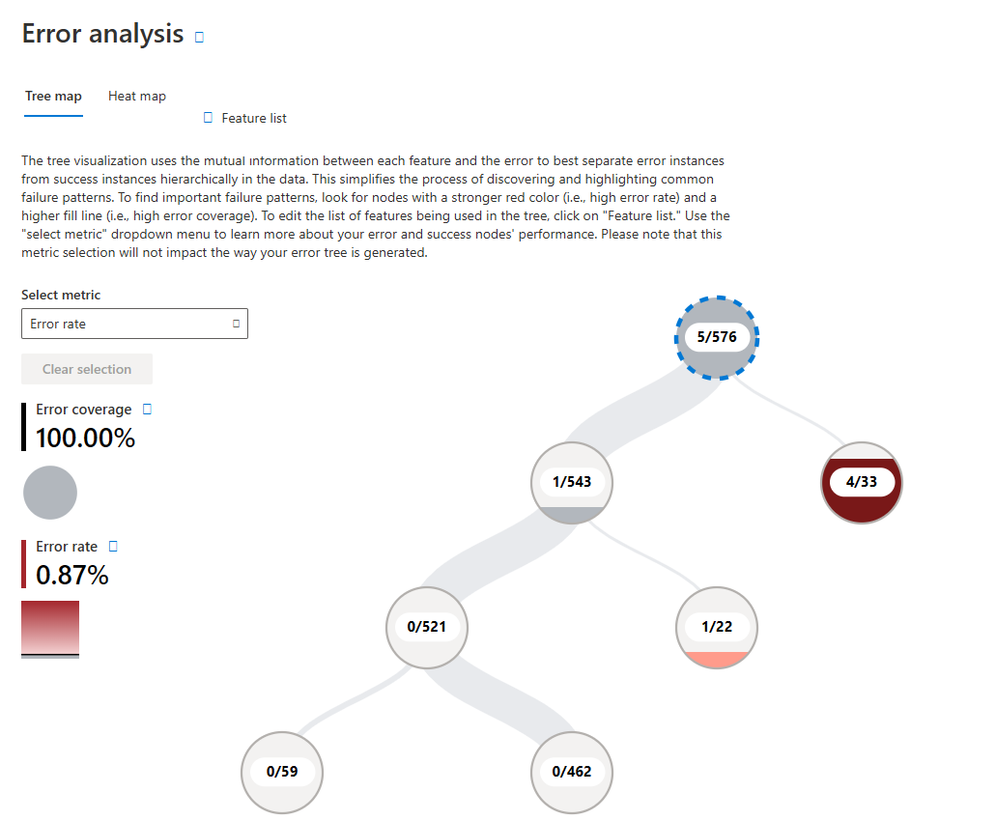
Accuracy : 0.991

Show that the retrain by adding data is sufficient

GPT generate 怎么写

加照片
- Error Analysis (The "Pareto Principle")
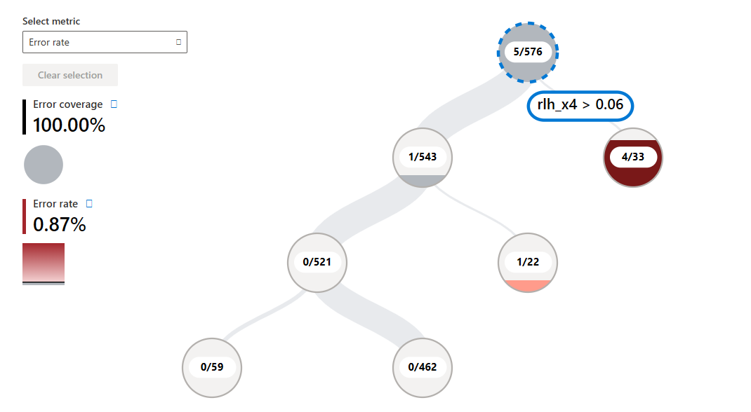
Change the condition of rlh_x4>0.06

B. Confusion Matrix Analysis (Vertical Spatial Overlap)
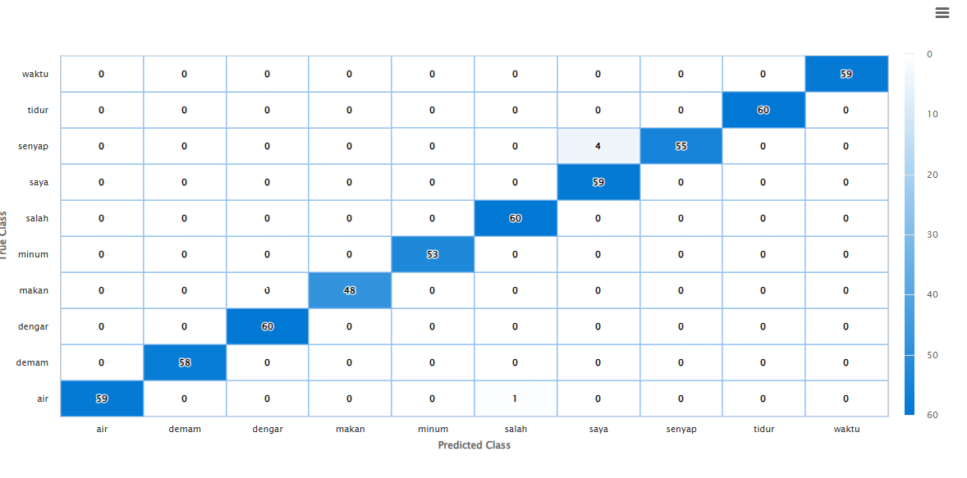

C. Fairness and Bias Check
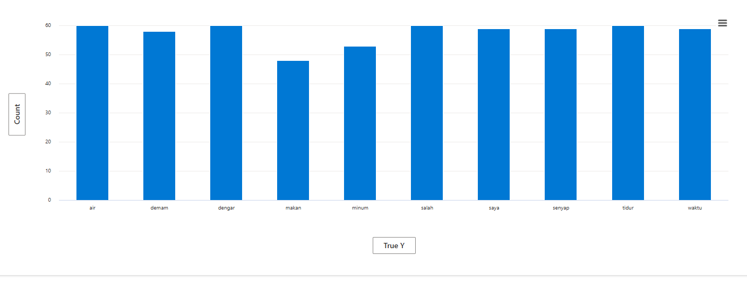

Features importance 删了

